Lesson 13 – Responsive Website

**Responsive Web Design:**

* Introduction: <https://www.w3schools.com/css/css_rwd_intro.asp>
* CSS Viewport: <https://www.w3schools.com/css/css_rwd_viewport.asp>
* CSS Media Query: <https://www.w3schools.com/css/css3_mediaqueries.asp>

**Task:**

* Apply a **responsive design** philosophy to your website.
* Use the stylesheet with **horizonal menu** (created on the last lesson) for **mobile** **devices**.
* Use the stylesheet with **side menu** (created previously) for **large screens**.

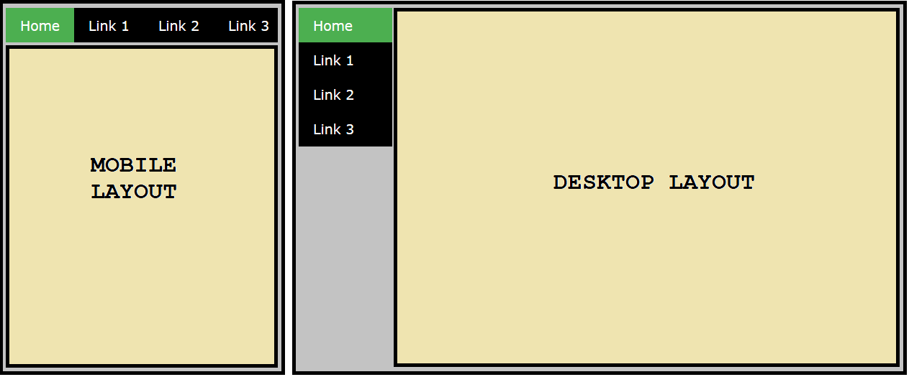

Instructions:

1. First, make sure you have **finished the stylesheet** with a **horizontal menu** (by following the instructions from the previous lesson. ***If NOT, do it FIRST!***
2. Rename the stylesheet with a **horizontal** **menu** to "mobile.css".
3. Rename the stylesheet with a **side** **menu** to "desktop.css".
4. Within the **header** of *all the pages*, edit the **link** to your stylesheets as follows:

<link rel="stylesheet" media="screen and (**max**-width: 400px)" href="mobile.css" />

<link rel="stylesheet" media="screen and (**min**-width: 400px)" href="desktop.css" />

1. **Test** the result by changing the **size of a browser window**.
2. **Test** the result by uploading the website to your **NAS www folder** and opening it in a mobile device.
3. Access the page via these links (don’t forget to replace **NameSurname** with your **login**):
   * unsecured HTTP protocol:
     + [http://gymeske.synology.me:1080/~**NameSurname**/index.html](http://gymeske.synology.me:1080/~NameSurname/index.html)
   * secured HTTPS protocol:
     + [https://gymeske.synology.me:1443/~**NameSurname**/index.html](https://gymeske.synology.me:1443/~NameSurname/index.html)

Optional:

1. Create an additional Black&White stylesheet applicable only for **page printing**.
2. Test the result by printing the page as **PDF**.